Recognizing Text in Images

Write an optical character recognition application that identifies and recognizes printed text within an image.

By: Eric Herman
Professor: Dr. McVey-Pankratz

Table of Contents

1.1 Executable Installation Instructions Pg. 3
1.2 Open/Run in PyCharm Pg. 4
2.1 Structure Diagram Pg. 5
2.2 Data flow Diagram Pg. 6
3.1 Interface Pg. 7
3.2 How to open image Pg. 8
3.3 How to use live video Pg. 9
3.4 How to take a picture Pg. 10
3.5 How to improve results Pg. 11 - 12
3.6 How to search results Pg. 13
4.1 Code Pg. 14 - 25

1.1 Executable Installation Instructions

Install Instructions

1. Unzip OCR Program.zip on device designated device.

2. Open file names OCR Program

3. Run OCR Reader.exe

Troubleshooting

Nothing happens when selecting "Live video” - A camera device is not detected on your device. Check drivers and test with windows camera application restart application.

Nothing happens when the search button is pressed - Ensure that chrome is installed at "C://Program Files (x86)//Google//Chrome//Application//chrome.exe". If not move chrome folder to this location and restart application.

1.2 Open/Run in PyCharm

Install Instructions

1. Install PyCharm
2. Create new project
3. Navigate to virtual environment and move main.py into directory. Mine was “C:\Users\[username]\PycharmProjects\pythonProject”.
4. Put image in “C:\Users\[username]\PycharmProjects\pythonProject\venv\images” named “sign.PNG”.
5. pip install OpenCV, Pillow, pytesseract, numpy, tkinter.
6. Install Tesseract from the tesseract website in the virtual environment directory.
7. Run Program

Troubleshooting

Tesseract is not installed – Ensure that tesseract is installed in correct directory.

sign.PNG not found – Make sure sign.PNG is in “C:\Users\[username]\PycharmProjects\pythonProject\venv\images”.

2.1 Structure Diagram
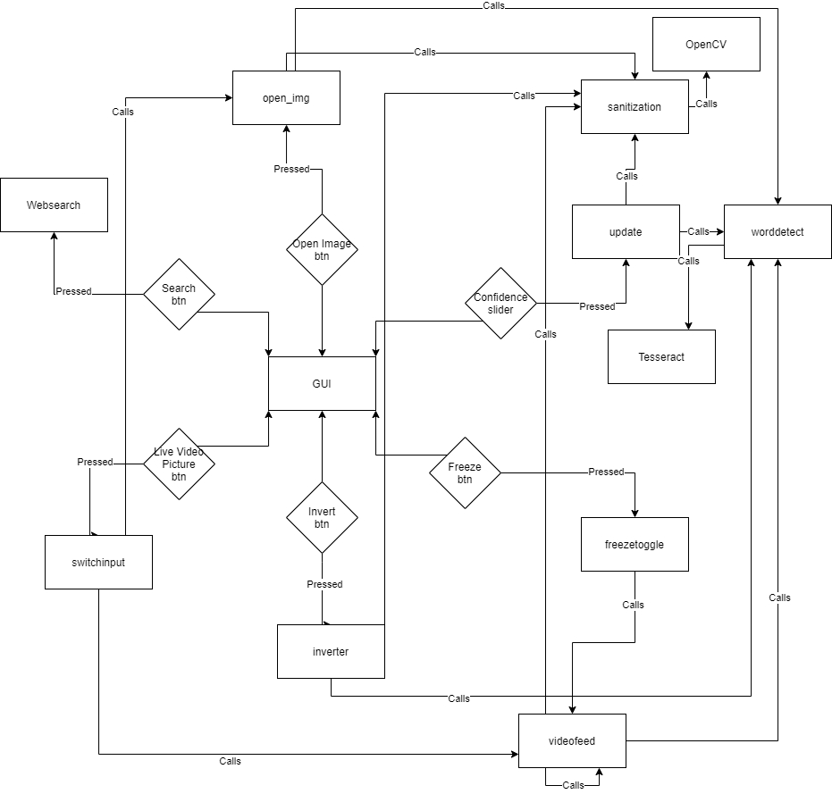

2.2 Data flow Diagram

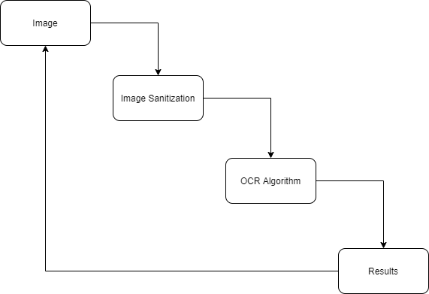

3.1 Interface
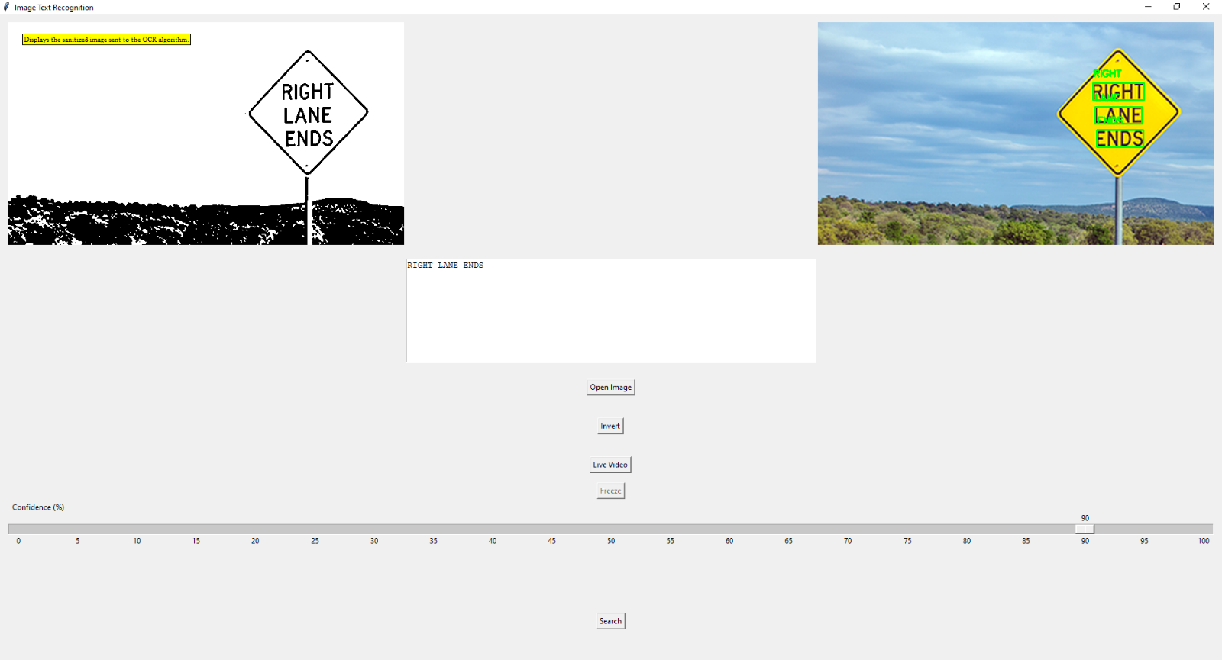
Sanitized Image
Original Image with AR
Results Box
Opens new image
Inverts the black to white and white to black
Toggles between Live video and pictures
Takes a picture
Adjusts confidence threshold
Does a Google search on results

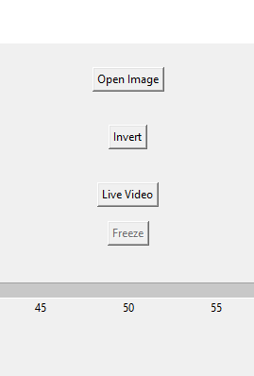
3.2 How to open image
Click Open Image
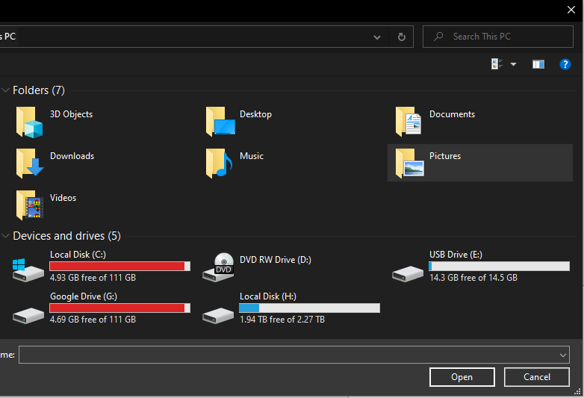

Find the Image you want to open but it must be a .png or .jpeg otherwise it will error.

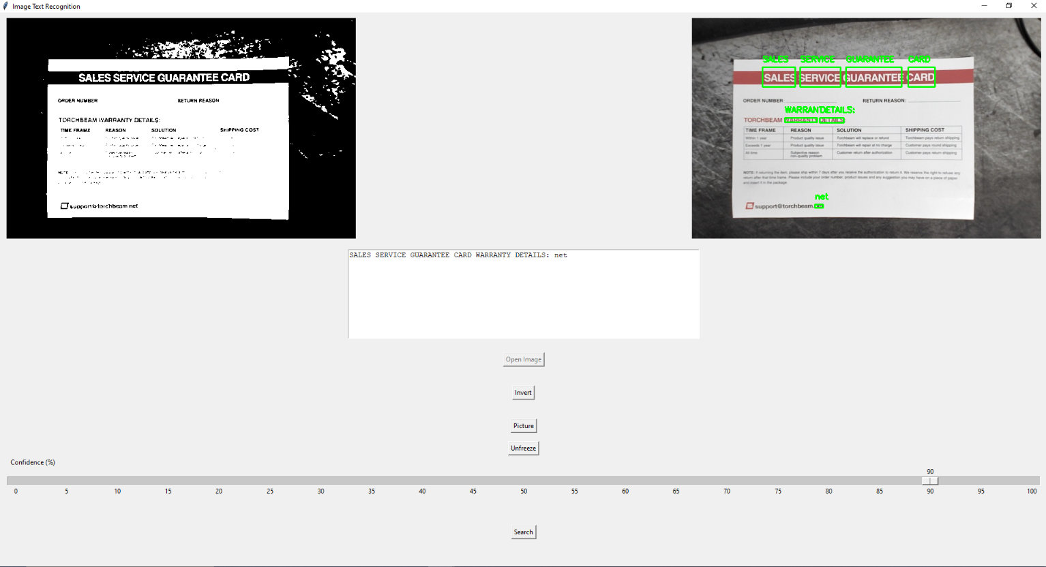
3.3 How to use live video
Click Live Video
If video does not appear, ensure drivers and camera are plugged in and restart application.

3.4 How to take a picture
Click Freeze

The image cannot be saved but you can go back to live video by pressing the unfreeze button.

3.5 How to improve results

Invert colors
The OCR algorithm prefers the use of black text on a white background.

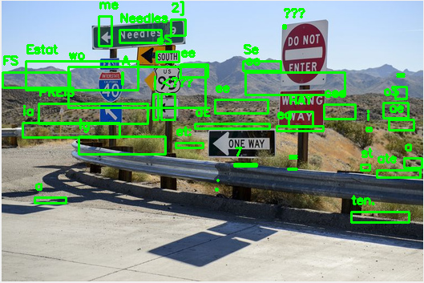
Confidence Threshold
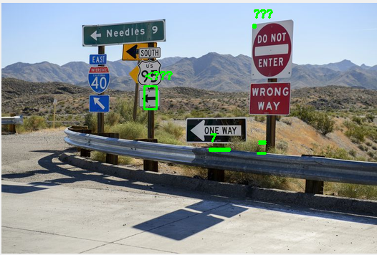
The image on the left displays the text that it is 65% or more confident that it is correct the one on the right is 0% to 100%.

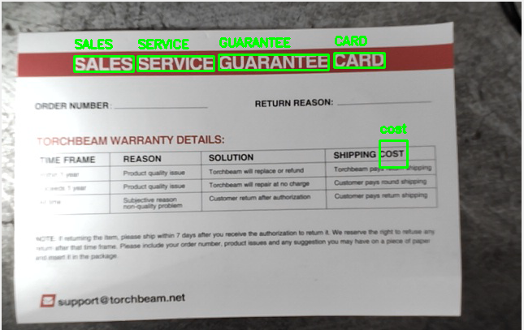
Lighting
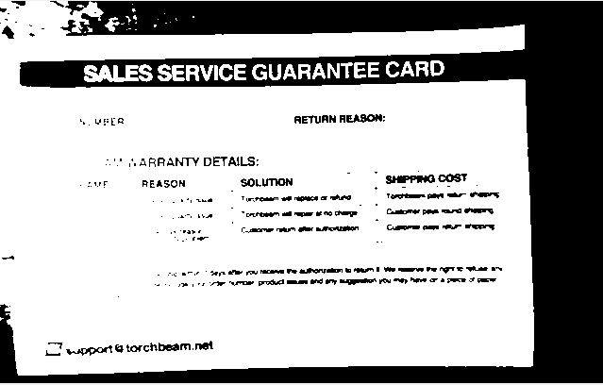
Gloss or semi-gloss surfaces can cause glare and will reduce the ability to read text. Avoid hot spots with too much light.

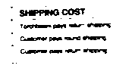
Text Size

If the text is readable then it most likely will be able to be read by the program. However, if the text is too small then it will no longer be able to be read.

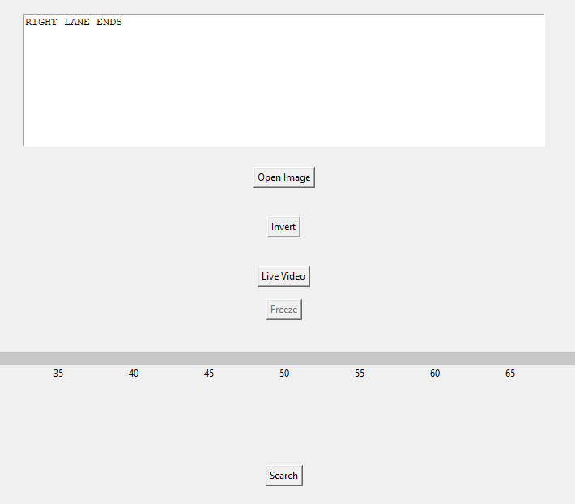
3.6 How to search results
Search Box
Click Search
Clicking Search will do a Google search of what ever is in the search box at the top.

4.1 Code
import cv2 as cv
import re
import PIL
from PIL import Image, ImageTk, ImageShow
import pytesseract
import numpy as np
from pytesseract import Output
import tkinter as tk

from tkinter import *
from tkinter import filedialog
from tkinter import messagebox
#from tkinter.tix import * #for balloon
import webbrowser

#print("Your opencv version is: " + cv2.__version__)
rectwidth = 20;
rectheight = 20;

class CreateToolTip(object): # makes the balloon messeges

def __init__(self, widget, text='widget info'):
self.widget = widget
self.text = text
self.widget.bind("<Enter>", self.enter)
self.widget.bind("<Leave>", self.close)

def enter(self, event=None):
x = y = 0
x, y, cx, cy = self.widget.bbox("insert")
x += self.widget.winfo_rootx() + 25
y += self.widget.winfo_rooty() + 20
# creates a toplevel window
self.tw = tk.Toplevel(self.widget)
# Leaves only the label and removes the app window
self.tw.wm_overrideredirect(True)
self.tw.wm_geometry("+%d+%d" % (x, y))
label = tk.Label(self.tw, text=self.text, justify='left',
background='yellow', relief='solid', borderwidth=1,
font=("times", "8", "normal"))
label.pack(ipadx=1)

def close(self, event=None):
if self.tw:
self.tw.destroy()

############################################################################################
# Description: Takes the original image and grayscales the image and threasholds and returns
# the cleaned image.
# Input: Image
# Output: Image
############################################################################################
def sanitization(img):
# displays original
#cv2.imshow('Original', frame)
# turns image to greyscale
gray = cv.cvtColor(img, cv.COLOR_BGR2GRAY) # turns image to greyscale

# displays greyscaled image
#cv.imshow('Greyscale', gray)
# blurs the image
#blur = cv.GaussianBlur(gray, (5, 5), 0)
#denoise = cv.fastNlMeansDenoising(gray) #improves acuracy sligtly

# displays the blured and greyscaled images
#cv.imshow('Greyscale+Blur', blur)
# thresholds the image
thresholded = cv.threshold(gray, 0, 255, cv.THRESH_BINARY + cv.THRESH_OTSU)[1] #Thresholds image
#thresholded = cv.adaptiveThreshold(gray, 255, cv.ADAPTIVE_THRESH_MEAN_C,cv.THRESH_BINARY,11,2)

# displays the blured, greyscaled and thresholds image
#cv.imshow('Greyscale+Threshold', thresholded)
return thresholded

# def boxingcontours(orig, contours): #opencv testing code of contours
# for cnt in contours:
# x, y, w, h = cv.boundingRect(cnt)
# if w > rectwidth and h > rectheight and w<orig.shape[1] and h<orig.shape[0]: # size of the possible contour rectangles
# rect = cv.rectangle(orig, (x, y), (x + w, y + h), (0, 0, 255), 2)
# cv.imshow('word detect', rect)
# return orig[y:y+h, x:x+w]
#detects individual chars in image
# def chardetect(frame,orig):
# height = orig.shape[0]
# width = orig.shape[1]
# custom_config = r'-l eng --psm 6'
# d = pytesseract.image_to_boxes(frame, output_type=Output.DICT, config=custom_config)
# n_boxes = len(d['char'])
# for i in range(n_boxes):
# #if int(d['conf'][i]) > accuracythresh:
# #(x, y, w, h) = (d['left'][i], d['top'][i], d['width'][i], d['height'][i])
# (text, x1, y2, x2, y1) = (d['char'][i], d['left'][i], d['top'][i], d['right'][i], d['bottom'][i])
# cv.rectangle(orig, (x1, height - y1), (x2, height - y2), (0, 255, 0), 2)
# # wordlength = len(d['text'][i])
# # print(wordlength)
# # letterwidth = w/wordlength
# # print(letterwidth)
# # for j in range(wordlength):
# # startx = int(x + (letterwidth * j))
# # width = int(startx + letterwidth)
# # orig = cv.rectangle(orig, (startx, y), (width, y + h), (0, 255, 0), 2)
# #orig = cv.rectangle(orig, (x, y), (x + w, y + h), (0, 255, 0), 2)
# print(text)
# #cv.waitKey(0)
#
# cv.imshow('Boxed', orig)

############################################################################################
# Description: Reads the text in the image and puts a box around the text along with the
# text that was found.
# Input: sanitized image, original image, confidence threshold
# Output: original image
############################################################################################
def worddetect(frame,orig, confidence):
global result
custom_config = r'--oem 3 -l eng --psm 6 ' # configuration of tesseract
d = pytesseract.image_to_data(frame,lang='eng', output_type=Output.DICT, config=custom_config) # Runs OCR on image
n_boxes = len(d['text'])
result.delete('1.0',END) # clears textbox
for i in range(n_boxes):
if int(d['conf'][i]) > confidence: # Only displays words with certain confidence threshold
(x, y, w, h) = (d['left'][i], d['top'][i], d['width'][i], d['height'][i]) # coordinates of the text
# cv.rectangle(orig, (x, y), (x+w, y+h), (255, 255, 255), -1)#covers text and overlays with what it reads
# cv.putText(orig, d['text'][i], (x, y+12), cv.FONT_HERSHEY_SIMPLEX, 0.5, (0,0,0), 2)
cv.rectangle(orig, (x, y), (x + w, y + h), (0, 255, 0), 2)#boxes text
cv.putText(orig, d['text'][i], (x, y - 10), cv.FONT_HERSHEY_SIMPLEX, 0.5, (0, 255, 0), 2)# writes text in top left of the box
result.insert(END, d['text'][i]) # writes in textbox
result.insert(END, ' ') # inserts space between words
#print(d['text'][i])
#print(d['conf'][i])
#cv.waitKey(0)

#cv.imshow('Boxed', orig)

# #Main Picture does the OCR on images only no interface
# frame = cv.imread('venv/Pictures/sign.PNG',1)
# #print(frame)
# sanitized = sanitization(frame)
# # contours, _ = cv.findContours(sanitized, cv.RETR_TREE, cv.CHAIN_APPROX_NONE)
# # cropped = boxingcontours(frame, contours)
# # sanitizedagain = sanitization(cropped)
# # worddetect(sanitizedagain, cropped)
# worddetect(sanitized,frame)
# # When everything done, release the capture
# cv.waitKey(0)
# cv.destroyAllWindows()

# def worddetect2(frame,orig):
# global result
# custom_config = r'--oem 3 -l eng --psm 6 '
# d = pytesseract.image_to_data(frame,lang='eng', output_type=Output.DICT, config=custom_config)
# n_boxes = len(d['text'])
# #result.delete('1.0',END)
# for i in range(n_boxes):
# if int(d['conf'][i]) > 80:
# (x, y, w, h) = (d['left'][i], d['top'][i], d['width'][i], d['height'][i])
# # cv.rectangle(orig, (x, y), (x+w, y+h), (255, 255, 255), -1)#covers text and overlays with what it reads
# # cv.putText(orig, d['text'][i], (x, y+12), cv.FONT_HERSHEY_SIMPLEX, 0.5, (0,0,0), 2)
# cv.rectangle(orig, (x, y), (x + w, y + h), (0, 255, 0), 2)#boxes text and writes what it reads on top
# cv.putText(orig, d['text'][i], (x, y - 10), cv.FONT_HERSHEY_SIMPLEX, 0.5, (0, 255, 0), 2)
# #result.insert(END, d['text'][i])
# #result.insert(END, ' ')
# #print(d['text'][i])
# #print(d['conf'][i])
# #cv.waitKey(0)
#
# cv.imshow('Boxed', orig)
#
# #Main Camera does camera feed without an interface
# cap = cv.VideoCapture(0)
# while (True):# Capture frame-by-frame
# ret, frame = cap.read()
# sanitized = sanitization(frame)
# worddetect2(sanitized, frame)
# if cv.waitKey(1) & 0xFF == ord('q'):
# break
# # When everything done, release the capture
# cap.release()
# cv.destroyAllWindows()

#gui interface displays camera feed
# width, height = 1080, 720
# cap = cv.VideoCapture(0)
# cap.set(cv.CAP_PROP_FRAME_WIDTH, width)
# cap.set(cv.CAP_PROP_FRAME_HEIGHT, height)
#
# root = Tk()
# root.bind('<Escape>', lambda e: root.quit())
# lmain = Label(root)
# lmain.pack()
#
# def show_frame():
# ret, frame = cap.read()
# if ret:
# sanitized = sanitization(frame)
# worddetect(sanitized, frame)
# cvimage = cv.cvtColor(frame, cv.COLOR_BGR2RGBA)
# img = PIL.Image.fromarray(cvimage)
# imgtk = ImageTk.PhotoImage(image=img)
# lmain.imgtk = imgtk
# lmain.configure(image=imgtk)
# lmain.after(10, show_frame)
#
# show_frame()
# root.mainloop()

############################################################################################
# Description: Opens image and then resizes converts to array and displays the original and
# detected word image on the screen when the Open Image button is pressed.
# Input: Nothing
# Output: Nothing
############################################################################################
def open_img():
global panelA, panelB, confslider, x, result, invert, freash #global variables
x = filedialog.askopenfilename(title='Choose file') #opens a explorer window to search for images
try:
freash = PIL.Image.open(x) #opens the image and sets it to the variable
except IOError:
messagebox.showerror("ERROR", "INVALID DATA TYPE MUST BE JPG OR PNG") #displays error message if file type is wrong
#print("invalid image type")

hsize = freash.size[1] # gets the height of the image
wsize = freash.size[0] # gets width of the image
freash = freash.resize((int((350 / hsize) * wsize), 350), PIL.Image.ANTIALIAS) # uniformly scales the image
orig = freash
img = np.asarray(orig) # converts image to array
#orig = ImageTk.PhotoImage(orig)
img = cv.cvtColor(img, cv.COLOR_BGR2RGB) # changes BGR to RGB
sanitized = sanitization(img) # runs sanitization on image
if invert['text'] == "Revert": # inverts black and white if invert is selected
sanitized = cv.bitwise_not(sanitized)
worddetect(sanitized, img, confslider.get()) # runs OCR on image

sanitized = cv.cvtColor(sanitized, cv.COLOR_RGB2BGR) # changes RGB to BGR
orig = PIL.Image.fromarray(sanitized) # converts the image back
orig = ImageTk.PhotoImage(orig) # changes format so that it works for tkinter
if panelA is None: # creates an image in panelA if not created
panelA = Label(root, image=orig)
panelA.image = orig
panelA.pack(side="left", padx=10, pady=10)
else:
panelA.configure(image=orig) # changes image to the new original
panelA.image = orig

img = cv.cvtColor(img, cv.COLOR_RGB2BGR) # changes RGB to BGR
frame = PIL.Image.fromarray(img) # converts the image back
frame = ImageTk.PhotoImage(frame) # changes format so that it works for tkinter
if panelB is None: # creates and image in panelB if not created yet
panelB = Label(image=frame)
panelB.image = frame
panelB.pack(side="right", padx=10, pady=10)
else:
panelB.configure(image=frame)# changes image to new modified image
panelB.image = frame

############################################################################################
# Description: Similar to open_img but is called when variables of the OCR or sanitization
# process are changed and then updates the graphical interface.
# Input: threshold value
# Output: Nothing
############################################################################################
def update(num):
global panelA, panelB, confslider, x, result, invert, freash
orig = freash
# hsize = orig.size[1]
# wsize = orig.size[0]
# orig = orig.resize((int((350 / hsize) * wsize), 350), PIL.Image.ANTIALIAS)
img = np.asarray(orig) # converts image to array
img = cv.cvtColor(img, cv.COLOR_BGR2RGB) # changes BGR to RGB
sanitized = sanitization(img) # sanitizes image
if invert['text'] == "Revert": # reverts if selected
sanitized = cv.bitwise_not(sanitized)
worddetect(sanitized, img, confslider.get()) # runs OCR
sanitized = cv.cvtColor(sanitized, cv.COLOR_RGB2BGR) # changes RGB to BGR
orig = PIL.Image.fromarray(sanitized) # converts image back
orig = ImageTk.PhotoImage(orig) # modifies image for Tkinter
if panelA is None: # updates panelA
panelA = Label(root, image=orig)
panelA.image = orig
panelA.pack(side="left", padx=10, pady=10)
#tip.bind_widget(panelA, balloonmsg="Displays the sanitized image sent to the OCR algorithm.")
panelA_ttp = CreateToolTip(panelA,"Displays the sanitized image sent to the OCR algorithm.")
else:
panelA.configure(image=orig)
panelA.image = orig

img = cv.cvtColor(img, cv.COLOR_RGB2BGR) # changes RGB to BGR
frame = PIL.Image.fromarray(img) # converts the image back
frame = ImageTk.PhotoImage(frame) # modifies the image for Tkinter
if panelB is None: # updates panelB
panelB = Label(image=frame)
panelB.image = frame
panelB.pack(side="right", padx=10, pady=10)
#tip.bind_widget(panelB, balloonmsg="Displays the output of what is found using the OCR algorithm with the results boxed on the original image.")
panelB_ttp = CreateToolTip(panelB, "Displays the output of what is found using the OCR algorithm with the results boxed on the original image.")

else:
panelB.configure(image=frame)
panelB.image = frame

############################################################################################
# Description: Does the logic of the invert and revert button in GUI along with updating the
# images.
# Input: Nothing
# Output: Nothing
############################################################################################
def inverter():
global panelA, panelB, confslider, x, result, invert, root, inversion, freash
orig = freash
# hsize = orig.size[1]
# wsize = orig.size[0]
# orig = orig.resize((int((350 / hsize) * wsize), 350), PIL.Image.ANTIALIAS)
img = np.asarray(orig) # converts to array
img = cv.cvtColor(img, cv.COLOR_BGR2RGB) # changes BGR to RGB
sanitized = sanitization(img) # sanitizes image
if invert['text'] == "Invert": # If inverts the it wil invert the image
sanitized = cv.bitwise_not(sanitized)
invert['text'] = "Revert"
else: # if revert then change to invert
invert['text'] = "Invert"
worddetect(sanitized, img, confslider.get()) # runs OCR
sanitized = cv.cvtColor(sanitized, cv.COLOR_RGB2BGR) # changes RGB to BGR
orig = PIL.Image.fromarray(sanitized) # converts image back
orig = ImageTk.PhotoImage(orig) # convert for Tkinter
if panelA is None:# update panelA
panelA = Label(root, image=orig)
panelA.image = orig
panelA.pack(side="left", padx=10, pady=10)
else:
panelA.configure(image=orig)
panelA.image = orig

img = cv.cvtColor(img, cv.COLOR_RGB2BGR) # changes RGB to BGR
frame = PIL.Image.fromarray(img) # converts the image back
frame = ImageTk.PhotoImage(frame) # converts for Tkinter
if panelB is None: # update panelB
panelB = Label(image=frame)
panelB.image = frame
panelB.pack(side="right", padx=10, pady=10)
else:
panelB.configure(image=frame)
panelB.image = frame

############################################################################################
# Description: Grabs a new frame from the camera every 200 ms and runs the worddetect function
# every new frame that is imputed.
# Input: Nothing
# Output: Nothing
############################################################################################
def videofeed():
global panelA, panelB, confslider, x, result, invert, root, inversion, freash, cameratoggle, btn, cap, vidcon
if vidcon: # if bool is true how to stop video feed
ret, frame = cap.read() # reads image
img = np.asarray(frame) # converts to array
img = cv.cvtColor(img, cv.COLOR_BGR2RGB) # to RGB
freash = img
if ret: # if there is an image from camera
sanitized = sanitization(frame) # sanitize image
if invert['text'] == "Revert": # keep inverted if inverted
sanitized = cv.bitwise_not(sanitized)
cvimage = cv.cvtColor(sanitized, cv.COLOR_BGR2RGBA) # to RGB
img = PIL.Image.fromarray(cvimage) # converts image back
imga = ImageTk.PhotoImage(image=img) # sanitized image in panelA
panelA.configure(image=imga)
panelA.image = imga
worddetect(sanitized, frame, confslider.get()) # runs OCR
cvimage2 = cv.cvtColor(frame, cv.COLOR_BGR2RGBA) # to RGB
img2 = PIL.Image.fromarray(cvimage2)
imgb = ImageTk.PhotoImage(image=img2) # applies OCR image to panelB
panelB.configure(image=imgb)
panelB.image = imgb
panelB.after(200, videofeed) # event timer for 200 ms
#videofeed();
# panelB.after(10, videofeed)
# worddetect(sanitized, frame)
# cvimage = cv.cvtColor(frame, cv.COLOR_BGR2RGBA)
# img = PIL.Image.fromarray(cvimage)
# imgtk = ImageTk.PhotoImage(image=img)
# lmain.imgtk = imgtk
# lmain.configure(image=imgtk)
# lmain.after(10, show_frame)

############################################################################################
# Description: Does the logic for toggling between live video and pictures.
# Input: Nothing
# Output: Nothing
############################################################################################
def switchinput():
global panelA, panelB, confslider, x, result, invert, root, inversion, freash, cameratoggle, btn, vidcon, camerafreeze
if cameratoggle['text'] == "Live Video":
btn["state"] = DISABLED
camerafreeze["state"] = NORMAL
cameratoggle['text'] = "Picture"
vidcon = True
videofeed()
else:
btn["state"] = NORMAL
camerafreeze["state"] = DISABLED
cameratoggle['text'] = "Live Video"
camerafreeze['text'] = "Freeze"
vidcon = False
open_img()

############################################################################################
# Description: Toggles the ability to freeze the live video feed and unfreeze.
# Input: Nothing
# Output: Nothing
############################################################################################
def freezetoggle():
global panelA, panelB, confslider, x, result, invert, root, inversion, freash, cameratoggle, btn, vidcon, camerafreeze
if camerafreeze['text'] == "Freeze":
camerafreeze['text'] = "Unfreeze"
vidcon = False
else:
camerafreeze['text'] = "Freeze"
vidcon = True
videofeed()

############################################################################################
# Description: Does a google search of what ever text is found in the textbox.
# Input: Nothing
# Output: Nothing
############################################################################################
def websearch():
global panelA, panelB, confslider, x, result, invert, root, inversion, freash, cameratoggle, btn, vidcon, camerafreeze, search
url = "https://www.google.com.tr/search?q={}".format(result.get(1.0, "end"))
webbrowser.register('chrome',None,webbrowser.BackgroundBrowser("C://Program Files (x86)//Google//Chrome//Application//chrome.exe"))
webbrowser.get('chrome').open(url)

root = Tk() # creates tkinter window called root
width, height = 525, 350 # resolution of video feed
cap = cv.VideoCapture(0) # handle for camera
cap.set(cv.CAP_PROP_FRAME_WIDTH, width) # applies width
cap.set(cv.CAP_PROP_FRAME_HEIGHT, height) # applies height
vidcon = True # video feed continue bool
x = 'venv/Pictures/sign.PNG' # default image on start up
freash = PIL.Image.open(x) # opens image
hsize = freash.size[1] # gets height
wsize = freash.size[0] # gets width
freash = freash.resize((int((350 / hsize) * wsize), 350), PIL.Image.ANTIALIAS) # uniform scale
inversion = False
panelA = None
panelB = None
root.title("Image Text Recognition") # sets title of window
# w, h = root.winfo_screenwidth(), root.winfo_screenheight()
# root.geometry("%dx%d+0+0" % (w,h))
#root.attributes('-zoomed', True)
root.state("zoomed") # opens application in full screen
#root.geometry("1000x600")
#root.resizable(width = True, height = True)
#tip = Balloon(root) # applies balloon pop up messages on root

search = Button (root, text = "Search", command = websearch ) # initalizes the search button
search.pack(side="bottom", padx="10", pady="50")
#tip.bind_widget(search, balloonmsg = "Does a google search on the results.") # creates pop-up text
search_ttp = CreateToolTip(search, "Does a google search on the results.")

confslider = Scale(root, from_=0, to=100,tickinterval=5, length=600, resolution=5, label = 'Confidence (%)', orient=HORIZONTAL, command = update) # initalizes the confidence slider
confslider.pack(side="bottom", fill="both", expand="yes", padx="10", pady="0")
#tip.bind_widget(confslider, balloonmsg = "Adjusts the confidence level threshold to improve or decrease the accuracy of the OCR algorithm. ") # creates pop-up text
confslider_ttp = CreateToolTip(confslider, "Adjusts the confidence level threshold to improve or decrease the accuracy of the OCR algorithm. ")

camerafreeze = Button (root, text = "Freeze", command = freezetoggle, state = DISABLED) # initalizes the freeze button
camerafreeze.pack(side="bottom", padx="10", pady="0")
#tip.bind_widget(camerafreeze, balloonmsg = "Allows for pictures to be taken when in live video feed mode.") # creates pop-up text
camerafreeze_ttp = CreateToolTip(camerafreeze, "Allows for pictures to be taken when in live video feed mode.")

cameratoggle = Button (root, text = "Live Video", command = switchinput) # initalizes the toggle button between live video and pictures
cameratoggle.pack(side="bottom", padx="10", pady="15")
#tip.bind_widget(cameratoggle, balloonmsg = "Toggles between live video feed and opening pictures already saved on your device.") # creates pop-up text
cameratoggle_ttp = CreateToolTip(cameratoggle, "Toggles between live video feed and opening pictures already saved on your device.")

invert = Button(root, text = "Invert", command = inverter) # initalizes the invert button
invert.pack(side="bottom", padx="10", pady="20")
#tip.bind_widget(invert, balloonmsg = "Changes all black to white and white to black in the image sent to the OCR algorithm.") # creates pop-up text
invert_ttp = CreateToolTip(invert, "Changes all black to white and white to black in the image sent to the OCR algorithm.")

btn = Button(root, text = 'Open Image', command = open_img ) # initalizes the open image button
btn.pack(side="bottom", padx="10", pady="15")
#tip.bind_widget(btn, balloonmsg = "Allows for the picture to be changed when in picture mode.") # creates pop-up text
btn_ttp = CreateToolTip(btn, "Allows for the picture to be changed when in picture mode.")
confslider.set(90)

result = Text(root, height = "10") # initalizes the textbox with results
result.pack(side="bottom",padx="10", pady="10")
#tip.bind_widget(result, balloonmsg = "Google search bar of results from the image.") # creates pop-up text
result_ttp = CreateToolTip(result, "Google search bar of results from the image.")

root.mainloop() # game loop esencially to make the GUI reactive

